Summary of Report
of
Consultancy Service to Study Implementation of North-South Connectivity to develop Nepal as international transit

1. Summary

The Objective of this Assignment was to Study on Implementation of North-South Connectivity to develop Nepal as an international transit hub for taking into account the business, social, technological aspects of the digital connectivity.
- Current status in connection with North-South connection
Nepal Telecom and NCELL have already optical fiber connectivity with India via Biratnagar-Jogbeni, Birgunj-Raxual and Bhairahawa-Sunauli and, with China via Rasuwagadhi and Tatopani. Nepal Telecom and China Telecom Global launched their services after the laying of optical fiber cables between Kerung in China and Rasuwagadi in Nepal. Connectivity with China gives Nepal an alternative to India for cyber connectivity and contributed for uninterrupted connections. Nepal last year joined the Belt and Road Initiative, which is China’s effort to develop a modern “Silk Road” connecting Asia with Europe, Middle East and Africa by road, railway, sea and air.
As part of the initiative, China is ready to extend the Chinese railway network into Nepal from Tibet. In the railway line and electrical transmission lines, Nepal could propose for the fiber connectivity to act as a transit point for the huge traffic from the North (China)-South (India) connectivity. India-Nepal-China optical fibre link could be a milestone to develop internet infrastructure across the regions. Nepal is connecting China via Rasuwagadhi-Kerung and initial bandwidth utilization is about 4Gbps. Nepal could play a lead role to become a transit point for transferring huge data traffic from India to China and vice versa and could also play role for exchange of international traffic globally. Similarly, Nepal could play a transit point for East-Asia, Europe and Asian Pacific regions The information superhighway connecting each District Headquarters through Optical Fiber Connectivity is being established within next 2 years through Mid-Hill Highway, however serious efforts shall be placed for the completion of the Project in time.
- Legislative provision for cross border connection
The provisions of Telecommunication Act, 2053 and Telecommunication Regulation, 2054 is important legislative provision for any telecom service providers/ISPs for connectivity. Network service License needs to be obtained in order to provide the Network services. NTA has introduced the Special Directive for Network Services in relation to regulate the International/national network connectivity services in Nepal. It is necessary to have Agreement between the Network service Providers and International Carriers in order to manage and exchange the data outside the country and such Agreement or MOU shall be submitted to the NTA prior to getting the permission from the NTA. Network Service providers can bring the international BW (data) through the international carriers either through establishing Gateways inside Nepal.
Nepal needs to formulate specific legislative provisions for cross border connection including telecom infrastructure development within the country and recommend to include the following issues:
- Mandatory requirements on the license with appropriate licensing fee
- Mandatory provision for security on operation of cross border connectivity
- Mandatory requirement on laying optical fiber underground ducts not only on cross border but also within the country in newly constructed major highways/ railways/ tunnel/ pipelines and OPGW deployment cross border electrical transmission lines by the implementing agency like Road Department for laying Optical Duct on Road and NEA for building OPGW in electrical transmission lines.
- Developing national standard for laying UG cabling including blowing optical fiber cable in the ducts.
- Developing legal provisions for sharing cross border communications routes and sharing infrastructure within the country among all Telcos/ISPs
- Best practices of cross border connections around the globe
Few decades back, most of the international traffic were carried through the international satellites around the globe. Now a days, most of the international data traffic is carried by the submarine cables, trans-continental optical cables (Cross Atlantic, Cross Pacific etc.) and UG/ADSS/Aerial optical fiber. In the recent past, there had been renewed interest in overland fiber-optic cables which are economical for laying down and are easier to maintain. They are riding piggyback on roads, railway lines, oil and gas pipelines which are appearing all over continental Asia.
 | Nepal | Bangladesh | Bhutan | India | Maldives | Pakistan | Sri Lanka | Turkey | Other Borders
Nepal | Optical and Microwave | Microwave Radio | SASEC | 1690Km border Multiple fiber links
Bangladesh | Microwave, SASEC |  |  | 4053Km Border Multiple fiber and radio links | No direct submarine links | Sea-Me-We-4 & Submarine | Sea-Me-We-4 Sea-Me-We-5 |  | Myanmar (193km) with fiber fiber
Bhutan | SASEC |  |  | 605km border multiple fiber links |  |  |  |  | China(470km) border not yet connected
India | 1096 km border Multiple fiber links | 4053km border multiple fiber links | 605km border multiple fiber links |  | WARF Telecom submarine cable | 2912 km border microwave and cable | Sea-Me-We-3, Sea-Me-We-4 , BLCS |  | China(3380km) multiple fiber links  Myanmar(1463km)- fiber links
Maldives |  | No direct submarine |  | WARF Telecom submarine cable |  | No direct submarine | Dhiraagu submarine cable, WARF sub cable
Pakistan |  | Sea-Me-We-4 |  | 2912 km border microwave and cable |  |  | Sea-Me-We-3,  Sea-Me-We-4 |  | Iran(909km)- fiber  China(523km) –fiber  Afganistan(268km)-fiber
Sri Lanka |  | Sea-Me-We-4 Sea-Me-We-5 |  | Sea-Me-We-3, Sea-Me-We-4 | Dhiraagu submarine cable, WARF sub cable | Sea-Me-We-3,  Sea-Me-We-4
Turkey | Iran(499 km)- multiple fiber links, Armenia(268km)-No connection, Azerbaijan(km)-fiber, Bulgaria(240km)-fiber, Georgia(252km)-fiber, Greece(206km)-fiber, Iraq(352km)-fiber, Syria(822km)-fiber connectivity are available
- Implementation of North-South Fiber connectivity
As India and China has long border, Nepal needs to get assurance from India and China on the utilization of Nepal’s network for transportation of Terabits of data via Nepal prior to implementation of North-South connectivity by the NTA/ GoN. Existing infrastructure of cross border connectivity by the existing Telcos like Nepal Telecom, NCELL and UTL may not be considered as enough for transporting outbound and inbound traffic of Nepal. Additional investment from NTA/ GoN is not recommended without assurance of utilization from neighboring countries.
After getting assurances, Nepal could opt following implementation plan for North-South connectivity.
- Laying of Optical Fiber cable on sides of roads and laying of ADSS optical cable on the electrical transmission pole/towers for making resilient network.
- Nepal shall have minimum of two point connectivity each with India and China. Nepal shall not rely only on one country for cross border connectivity.
- NTA/GoN may use RTDF funds for implementing cross border connectivity through the existing licensees of service providers (Telcos/ISPs) in similar current implementation model as for Province No. 1, 2, 3 for Nepal Telecom or establish a separate Department of communication under MoCIT and execute the same using PPP model.
- Proposed network diagram
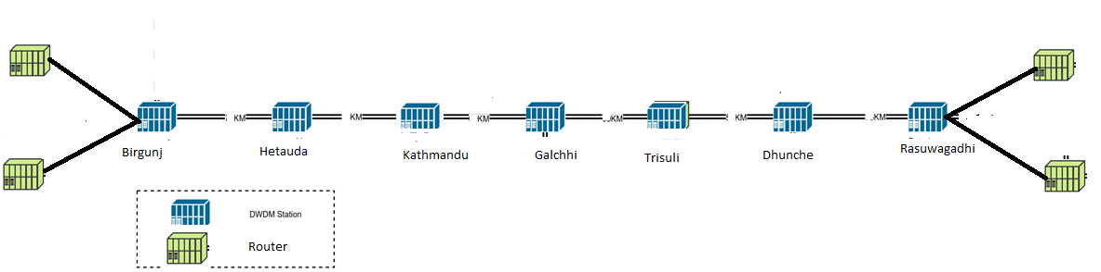
a: Sample Network Diagram from Birgunj to Rasuwagadhi (Schematic Only)
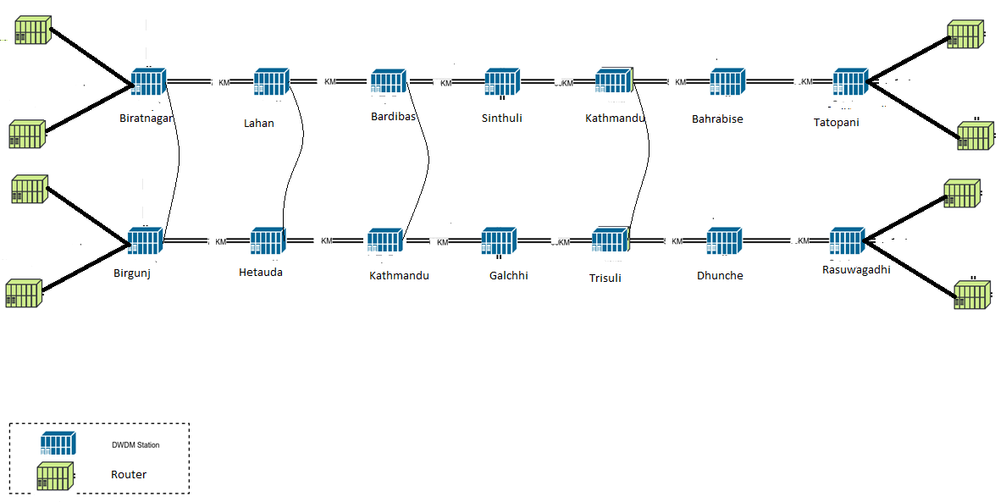
Figure 1: Sample Network Diagram for Umbilical Diversity from Birgunj/Biratnagar to Rasuwagadhi/Tatopani (Schematic Only)
Total Cost Estimate in US Dollar (Sample Calculation Only)

S/N | Route | Google Map Distance Km | Under Ground Cable (UG) | ADSS on NEA Pole/Tower Rent | ADSS with Pole | OPGW Rent/Annum | DWDM | Router
1 | Birgunj-Tatopani | 250 | 3,000,000 | 1,500,000 | 2,500,000 | 180,000 | 666,667 | 800,000
2 | Biratnagar-Tatopani | 410 | 4,920,000 | 2,460,000 | 4,100,000 | 295,200 | 1,093,333 | 800,000
3 | Birgunj-Rasuwagadhi | 450 | 5,400,000 | 2,700,000 | 4,500,000 | 324,000 | 1,200,000 | 800,000
4 | Bhairahawa-Korala | 600 | 7,200,000 | 3,600,000 | 6,000,000 | 432,000 | 1,600,000 | 800,000

- Appropriate technologies and capacity assessment.
North-South high capacity, reliable and resilient optical connectivity with DWDM and Routers having initial capacity of nx100Gbps and upgradable to nx400 Gbpswith 2+1 redundancy with umbilical diversity needs to be established at Nepal-India and Nepal-China borders for its’ own traffic movement. Optical connectivity could be laid on the sides of the road, railways and ADSS/OPGW on the pole/tower of electrical transmission lines.
- Technical aspects, service aspects, business aspect and organizational aspect
Benefits to consumers: Better, more cost-effective connectivity in the North-South and Asian region will greatly reduce consumer prices in less developed markets and improve broadband reliability throughout the region.
Economic growth and Improved ICT infrastructure: Increased demand for the output of other industries (demand multiplier), new opportunities for production in other industries (supply multiplier), new goods and services for consumers (final demand). It also increases firms’ innovation capabilities and increases the probability of new products, innovations, and organization expansion.
North-south connectivity has potential to increase government revenue growth in economic output from ICT investment results in greater tax revenue, increased employment in the telecommunications sector, greater collections from telecom licenses and royalty.
Cross country connectivity improves regional stability through better international and intercultural relations. More efficient routing of trans-border traffic would encourage trans-border initiatives in the education, healthcare, and research sectors that would not otherwise be possible.
- Potential points to connect India and China
Following are the proposed potential points to be connected with India and China:
- Nepal-India
Biratnager-Jogbani
Birgunj-Raxaul
Bhairahawa-Sunaul
Nepalgunj-Rupaidiya
- Nepal-China
Tatopani-Khasa
Rasuwagadhi-Kerung
Korala-Dhongasen
Hilsa- Borang
However, infrastructures (road, electricity) yet to be developed in some of the routes.
 | Nepal Government | Private | India | China | Remarks
Construction of fiber on Biratnagar-Bardibas-Tatopani | SASEC route/ OPGW of NEA/ UG/ADSS of NT | UG/ADSS of NCELL/UTEL/ Other Telcos/ ISPs | Connectivity with Biratnagar-Jogbani | Connectivity with Tatopani- Khasha | Sharing of Infrastructure
Construction of fiber on Birgunj-Hetauda-Rasuwagadhi | RTDF Route /OPGW of NEA/ UG/ADSS of NT | UG/ADSS of NCELL/UTEL/ Other Telcos/ ISPs | Connectivity with Birgunj-Raxaul | Connectivity with Rasuwagadhi- Kerung | Sharing of Infrastructure
Construction of fiber on Bhairahawa- Pokhara-Korala-China | RTDF Investment/ OPGW of NEA/ UG/ADSS of NT | UG/ADSS of NCELL/UTEL/ Other Telcos/ ISPs | Connectivity with Bhairahawa- Sunaul | Connectivity with Korala-China Naka | New Construction required
Construction of fiber on Nepalgunj-Surekhet- Humla- Hilsa-Borang-China | RTDF Investment/ OPGW of NEA/ UG/ADSS of NT | UG/ADSS of NCELL/UTEL/ Other Telcos/ ISPs | Connectivity with Bhairahawa- Sunaul | Connectivity with Korala-China Naka | New Construction required
Construction of fiber on Proposed Railway Lines India-Nepal-China | RTDF Investment/ OPGW of NEA/ UG/ADSS of NT | UG/ADSS of NCELL/UTEL/ Other Telcos/ ISPs | Connectivity with Nepal-India Naka | Connectivity with Nepal-China Naka | New Investment and Construction required
Construction of fiber on Proposed Electrical Transmission Lines India-Nepal-China | RTDF Investment/ OPGW of NEA/ UG/ADSS of NT | UG/ADSS of NCELL/UTEL/ Other Telcos/ ISPs | Connectivity with Nepal-India Naka | Connectivity with Nepal-China Naka | New Investment and Construction required
Construction and Implementation of SASEC Highway/ MW with Bangladesh | RTDF Investment/ OPGW of NEA/ UG/ADSS of NT | Works as Users | Commitment | - | Multiparty commitment required
Launching of Communications Satellite | Nepal Government/ Donor/ G2G Model | Shareholders | Connectivity with Nepal-Other countries | Connectivity with Nepal-Other countries | New Construction required

- Methodology /entity responsible for dispute resolutions
Disputes should be resolved by the joint meeting of concerned operators of two countries. In case the disputes are not resolved by the joint meeting, then a bilateral committee comprising of members designated by respective government should be formed from the two governments of Nepal-India and Nepal-China. The decision made by the bilateral committee shall be the final and both parties shall obey the decisions.
- Securities issues
For the reliability of the network, the umbilical diversity is expected to address the problems associated with the natural disasters. During the construction of the fiber cable, secure routes should be identified. For the protection and security of the optical fiber cable, international standard practice (1.3m for normal soil and 0.8m for soil with stone and gravel terrain or short span of ADSS on rocky terrain) and secured paths should be strictly followed.
Security guards may be posted at sensitive nodes to avoid possible vandalisms.
For data protection of data over the optical fiber links, standard end to end encryption may be used. Similary cybersecurity norms applicable for reliable and trustworthy network and services shall be ensured. It is understood that the standards for cybersecurity is being brought through IT act by the GoN. It is necessary to update the cybersecurity legal provisions including standards to ensure privacy and security.
Possible Global Connectivity using Submarine Cable via North-South Connectivity is identified with cable length, owners and landing points.
Settling inter countries and inter-operator disputes in case of dispute:
National coordination Mechanism:
- Dispute between the Operators and Dispute between the Operator and Customers
As per the provision of Telecom Act, 2053 and dispute among/between the entities being regulated the Authority or between the concerned Regulatory Authority/ies. Provision for Structure of the Coordination Committee is recommended in relation to construction, establishment, operation and maintenance the Infrastructure Connectivity with clear roles and responsibilities of the committee. Also the procedure for dispute resolution is included in the report.
Inter-country Dispute Settlement
The transparent mechanism for the dispute resolution applicable to bilateral or multilateral cross-border issues or inter-country issues in relation to Infrastructure Connectivity based upon the consensus and relevant international best practices taking into account the consideration of International Agreement and Resolution while setting Dispute resolution between the countries including taken into account the WCIT Resolution 1: Special measures for landlocked developing countries and small island developing states for access to international optical fibre networks for the special situation of telecommunication/ICT services in LLDCs and SIDS, taking into account the importance of access to international fibre-optic networks at reasonable cost; with measures taken with respect to the assistance provided to LLDCs and SIDS under resolves to govern and promote sustainable regional, subregional, multilateral and bilateral projects affording them greater access to international fibre-optic networks.
Recommended national Legal Provision:
It is hereby recommended to bring national strategy and directives for the North south Connectivity for Information Highway/Superhighway. Since there is involvement of different cross ministerial entities such as Utilities provider e.g DoR, NEA, NTA, operators, it is appropriate to develop and approve the Legal document from the GoN and make enforce to the concerned entities through their respective authorities with necessary coordination.

x. Strategy and regulatory mechanism for implementation of North-South Fiber connectivity is developed. Major issues included in the regulatory framework include the followings:
- Background
- Advantages of submarine cables
- Necessary to Develop Standards and rules regarding the transit charges on trans-multi-country terrestrial cables
- The major principles to Guide Future Network Development
- Appropriate technologies including infrastructure capacity assessment
- Different Strategic Models for implementation of North-South Fiber connectivity
- International and Regional Infrastructure
- Backbone Network Infrastructure
- Access Network Infrastructure and connectivity
- Submarine Cable Connectivity
- Competition and Limited Open Access Regulations
- Open Access in International Submarine or Terrestrial Cables
- Infrastructure Deployment and developing competition
- Holistic Approach to Expand National Infrastructure through Sharing
- Utilization of Infrastructure of Utilities companies
- Utilization of OPGW commissioned on Powergrid
- Coordination with DOR for Duct
- Joint Infrastructure Deployment
- Government-Led Initiatives to Deploy National Backbone Infrastructure
- Regional collaborations
- Highway Construction Projects
- Transit Hub for SAARC Countries
- North-South high capacity reliable and resilience optical connectivity
- Four Routes on Nepal-India Cross Border
  - Biratnagar-Jogbani Route
  - Birgunj-Raxual Route
  - Bhairahawa-Sunaul Route
  - Nepalguj-Rupaidiya (proposed new route) Route
- Four Routes in Nepal-China Cross Border
  - Tatopani-Khasha Route
  - Rasuwagadhi-Kerung Route
  - Korala-Dhongbang Route and
  - Hilsa-Borang Route
- SASEC information Highway
- Connectivity linked to SAARC and other Countries
- Connectivity linked to SAARC and other Countries in 2 phases one for existing and other for new proposed routes
- Standardization of Infrastructure
- Dispute settlement mechanism for domestic and bilateral case

- Conclusions and Recommendations
North-South high capacity reliable and resilient optical connectivity with DWDM and Routers having initial capacity of nx100Gbps and upgradable to nx400Gbps with 2+1 redundancy with umbilical diversity needs to be established at Nepal-India and Nepal-China borders for its’ own traffic movement. However, further bilateral and trilateral consultation with India and China is recommended prior to implementation of North-South Connectivity to develop Nepal as “International Transit Hub”. Once the consultation becomes successful, North-South Connectivity should be planned to link up to SAARC countries, Middle East, EU, Americas, Oceania, Africa, Asia Pacific regions via India using submarine cables and linked to the different corridors such as Bagladesh-China-India-Myanmar corridor, Indo-China Peninsula corridor, China-Pakistan Corridor, China-Central Asia-West Asia corridors, China-Magnolia-Russia and East Asia corridor via China.
Four proposed routes on Nepal-India cross border links are Biratnagar-Jogbani, Birgunj-Raxual, Bhairahawa-Sunaul and Nepalguj-Rupaidiya (proposed new route). Similarly four other cross border links are proposed in Nepal-China border are Tatopani-Khasha, Rasuwagadhi-Kerung, Korala-Dhongbang and Hilsa-Borang. SASEC information highway may also be considered for the expansion of the North-South connectivity to the other neighboring countries Bhutan and Bangladesh.
North-South connectivity should be carried out in two phases:
Phase I : Existing routes
Jogbani-Biratnagar-Kathmandu-Tatopani-Khasa
Raxaul-Birgunj-Hetauda-Rasuwagadhi-Kerung
SASEC highway connecting Nepal-India-Bhutan-Bangladesh
Muzaffarpur-Dhalkebar(400KV/145Km)-Kathmandu-Tatopani/Rasuwagadhi OPGW routes
Phase II: New Proposed Routes
For connecting to highly reliable China Pakistan Economic Corridor (CPEC) optical fiber link to Pakistan further connecting to Central Asian SILK road, Rupaidia (India)-Nepalgunj-Surkhet-Jumla-Hilsa-Borang(China) links needs to be established in the future.
Sunauli(India)-Bhairahawa-Pokhara-Baglung-Mustang-Korala-Zhongha(China) along Kaligandaki corridor. The North-South fiber Connectivity shall be used on the infrastructure sharing model and new connectivity shall be built either by using RTDF fund or PPP model. New major North-South constructions are recommended to lay ducts on road and railways lines and OPGW lines on electrical transmission lines. NTA is recommended to advise Government of Nepal (GoN) to make it mandatory through the introduction of legal provisions. The first priority shall be given to use/build OPGW lines wherever applicable.
For operation and maintenance of the North-South connectivity, NTA may opt existing RTDF Build, Construct, Operate, Lease and Maintain model or PPP model with a consortium of major operators, government designated entity or Build, Own Operate and Lease (BOOL) model as existing NEA OPGW lines. Also the Regulatory Framework was developed and recommended for approval.

